2021-2022
Spokane Public Schools
Elementary Supply List

General classroom supplies such as pencils, glue, crayons, scissors, markers and tissue are provided by the school district.
The following are recommended for students to bring to school.

Kindergarten – Grade 2
Gym shoes for Fitness & Health
Backpack with student name clearly printed inside

Grade 3
2 Composition notebooks
2 Spiral notebooks, 8.5”x11”, 70-sheet, wide ruled
1 package 8-12 colored pencils
Gym shoes for Fitness & Health
Backpack with student name clearly printed inside

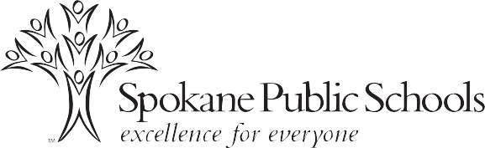

Grade 4
Accordion File (preferred) or a 2 inch 3-ring binder
Notebook paper – College Ruled
3 Composition notebooks
3 Portfolio folders with pockets
1 package subject dividers for 3-ring binder (if purchasing a binder)
Pencil/supply pouch
1 package 8-12 colored pencils
Gym shoes for Fitness & Health
Backpack with student name clearly printed inside (no suitcases or backpacks with wheels – must fit in a locker)

Grades 5
3-ring binder with a zipper (like a Trapper Keeper)
2 pks Notebook paper – College Ruled
1 Composition notebook
5 Portfolio folders with pockets, 3-hole
5 Spiral notebooks, 8.5”x11”, 70-sheet
4 Pens
2 Highlighters
1 package subject dividers for 3-ring binder
Pencil/supply pouch to place inside 3-ring binder
12-inch ruler with centimeters and inches
1 package 8-12 colored pencils
Gym shoes for Fitness & Health
Backpack with student name clearly printed inside (no suitcases or backpacks with wheels – must fit in a locker)

