Student Homepage Tiles

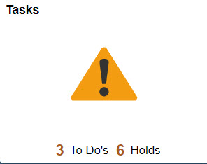
Profile Tile:
Tasks Tile:
To Do Lists
Holds

Personal Details
Contact Details
Addresses
Emergency Contacts
Ethnicity
Privacy Restrictions

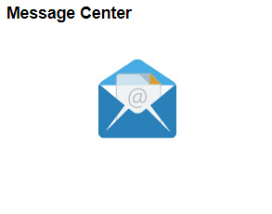
Manage Classes:
View My Classes
View My Exam Schedule
Enrollment Dates
Class Search and Enroll
Enroll by My Requirements
Shopping Cart
Drop, Update and Swap Classes
Browse Course Catalog
Planner

Message Center Tile:
Message Center

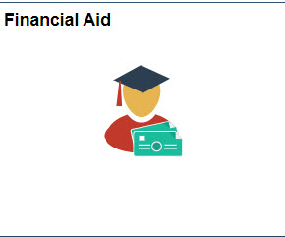
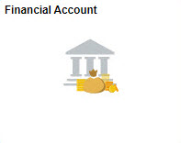
Financial Aid:
Aid Year Information
Accept and Decline Awards
Satisfactory Academic Progress (SAP)
Loan Counseling

Financial Account:
Account Balance
Charges Due
Payments
1098 T (Tax Information)
Payment Plans

Academic Progress:
Academic Progress
View What-If Reports
Advisors
View My Advising Notes
Apply for Graduation
View Graduation Status

Academic Records:
Course History
View Grades
View Unofficial Transcripts
View Transfer Credit Report
Evaluate Transfer Credit
View My Milestones

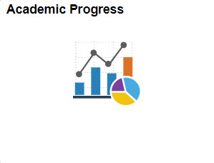

Profile Tile:
- Personal Details – Review name information and add preferred name.
- Contact Details – Review, add and edit contact details, such as; email and phone numbers.
- Addresses – Review, add and edit addresses.
- Emergency Contacts – Review, edit and add emergency contact information.
- Ethnicity – Review and update ethnicity and background information.
- Privacy Restrictions – Review and update privacy restrictions, such as; names, personal data, phone numbers, addresses, email addresses, extracurricular activities, and photograph.

Tasks Tile:
- To Do Lists – Review and respond to To Do List items on your student account.
- Holds – Review holds on your student account. These can be positive or punitive.

Message Center Tile:
- Message Center – Review and respond to messages sent to you by various different departments within your institution.

Manage Classes Tile:
- View My Classes – View the classes you are enrolled in for the term.
- View My Exam Schedule – View your final exam schedule for the term.
- Enrollment Date – View your enrollment dates for terms in the academic year.
- Class Search and Enroll – Search for classes by keywords and enroll in classes.
- Enroll by My Requirements – Review your Academic Advisement Report and enroll by classes that are not yet fulfilled.
- Shopping Cart – Review and Enroll in classes from your Shopping Cart. You can also validate that the courses in your Shopping Cart are still open or what is needed for your program.
- Drop, Update and Swap Classes – Ability to drop, update (if your institution allows) and swap classes based on your institutions academic calendar.
- Browse Course Catalog – Search for classes in the course catalog.
- Planner – Review, add and edit your educational planner.

Financial Account Tile:
- Account Balance – Review your account balance
- Charges Due – Review details about charges that are due on your student account
- Payments – Make payments on your student account
- 1098 T (Tax Information) – Review and authorize electronic delivery of your 1098-T Tax Information
- Payment Plans – Sign up for and make payments on a payment plan

Financial Aid Tile:
- Aid Year Information – Review your awards for the given academic year.
- Accept and Decline Awards – Ability to accept and decline awards.
- Satisfactory Academic Progress (SAP) - Review your SAP status and review your Institutional SAP Policy.
- Loan Counseling – Review and complete your Loan Counseling.

Academic Records:
- Course History – Review previous course history.
- View Grades – view grades for the current term.
- View Unofficial Transcripts – Review your unofficial transcript.
- View Transfer Credit Report – View any transfer credits applied to your student record.
- Evaluate Transfer Credit – Evaluate how transfer credits will be applied to a given program or institution.
- View My Milestones – Review milestones placed on your student account.

Academic Progress:
- Academic Progress – Review the status of your academic progress as it applies to your program.
- View What-If Reports – Run What-If reports for programs other than the program that you are currently perusing.
- Advisors – View your assigned advisor(s) and their contact information.
- View My Advising Notes – View and respond to notes sent by advisors.
- Apply for Graduation – Complete your application for graduation.
- View Graduation Status – Review where your graduation application is in the process.

