Course Standards
CREATE
Generate and conceptualize…organize and develop…refine and complete artistic work.
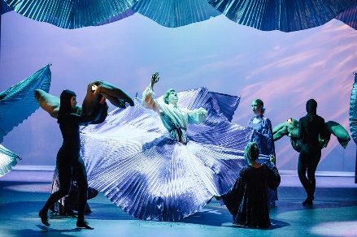
The Little Mermaid - 2022
PERFORM
Select, analyze, and interpret …develop and refine artistic techniques…convey meaning through presentation of artistic works.
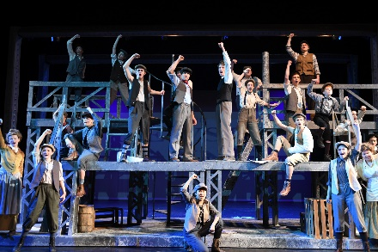
Newsies - 2019
RESPOND
Perceive and analyze…interpret intent and meaning…apply criteria to evaluate artistic work.
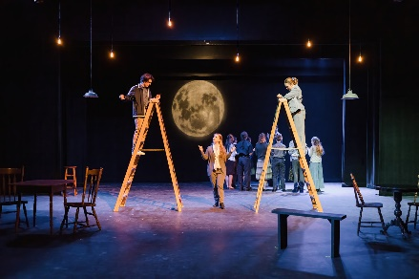
Our Town - 2022
CONNECT
Synthesize and relate knowledge and personal experiences…relate work with societal, cultural, and historical context to deepen understanding.
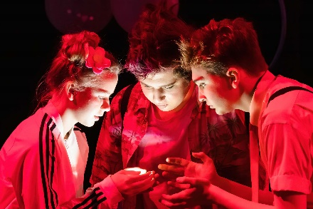
The SpongeBob Musical - 2021
Beginning Theatre
Mr. Pschirrer – room 129
gregp@spokaneschools.org
Mission | To provide our students and community opportunities for entertainment, enrichment, & education through exceptional theatre arts and the applicable life skills theatre develops.
Vision | Tiger Drama establishes an environment where all members challenge themselves as individuals, collaborate with others to create their best work now, and connect with other artists in and outside Lewis & Clark High School to be lifelong supporters of the arts.
Expectations
Engage. To grow as an artist, you need to commit to your work. Listen, put forth effort, and avoid distractions (especially personal devices!)
Be Bold. Take risks. Make choices. Try things without the guarantee of success. Taking chances and truly engaging in discovery are the keys to learning.
Show Respect. For this class to be successful, we must feel safe and comfortable. Show respect for your teacher, yourself, and your classmates. Do work that you can be proud of and come prepared to listen and participate.

Grading/Late Work
For more information, see District Grading Policy document Procedure 2420
Grading is based on meeting course standards and rubrics will be used to assess standards/provide feedback.

In a performance-based class, each student’s involvement impacts every other student’s learning opportunities. You will not be able to demonstrate learning if you do not actively participate.
CREATING - Direct involvement in class activities and interaction with the rest of the class. You’ll have a hard time meeting this standard if you struggle with tardiness/attendance.
PERFORMING – Talent is not a consideration in grading/meeting a standard. You demonstrate your learning through setting and meeting goals throughout the year. If you are unprepared to perform, it demonstrates that you have not met the standard and your grade will reflect that.
RESPONDING – Consistent reflection is how we grow. As you respond to your own work and the work of your peers, your skills will develop, and you will demonstrate the variety of skills you are learning in this class.
CONNECTING – You will demonstrate meeting standards in this area through your critiques and sharing your thoughts in class discussions/activities.
LATE WORK - 10% reduction per day late. This bottoms-out at half credit.
Late work will only be accepted up to the end of the quarter/designated grade cutoff date.
YOU WILL HAVE TO MEMORIZE LINES AND PERFORM IN-FRONT OF THE CLASS.
www.tigerdrama.com
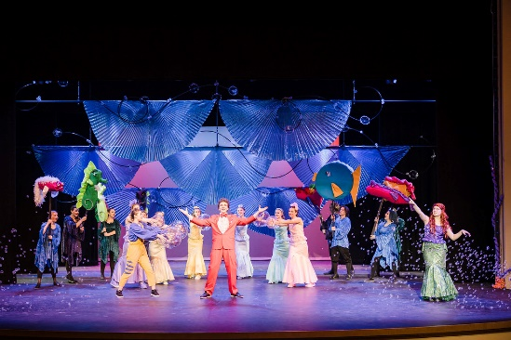  The Little Mermaid - 2022 | Attendance
 | To earn a passing grade, students must spend a great deal of time involved in group activities. Students who are frequently absent/tardy cannot adequately contribute to or demonstrate their learning through group projects. Absence from class impacts everyone’s learning opportunities. Everyone is a vital part of the class, and your presence is required for all of us to be successful. If health concerns impact your attendance, we will pursue alternative ways to demonstrate learning.
Class/Rehearsal Dress Code |  | Legally Blonde - 2011
Because this class focuses on creating characters and physical movement, proper clothing and shoes are required. Students should wear clothing that they can move easily in and feel comfortable sitting on the ground in. Closed toed shoes are recommended. Flip flops, high heels, and other clumsy footwear pose a serious safety risk. If you do not wear appropriate shoes or clothing to school, please bring appropriate attire and change into it before class begins.

2022-2023 Important Dates
September 12/13 Opening Night Auditions
September 26/27 Legally Blonde Auditions
October 6 Opening Night
October 29 INTAF @Ferris High School
December 8-10 Legally Blonde Performances
December 14 Thespy Registration Deadline
January 9/10 Sense & Sensibility Auditions
January 14 Thespy East Regional Event
March 9-11 Sense & Sensibility Performances
March 16-18 State Thespian Festival @ WWU
March 29 AT Performance and Showcase
April 20-22 Frozen Performances
May 1/2 Closing Night Auditions
May 24 Thespian Induction & Award Night
May 25 Closing Night

Intermediate Theatre CRITIQUES DUE DATES:
Jan. 5 and May 18

www.tigerdrama.com
Audition Information and FAQ
Shows/Events/Opportunities
Thespian Information
Event Registration
Production History
Xanadu – 2019
Outside Requirements
Although there are no outside requirements associated with class, Beginning and Intermediate Theatre students have the opportunity to audition for productions, work on crews, attend festivals, and participate in Thespian events. Specific details can be found on tigerdrama.com.

Intermediate Theatre Critiques
Intermediate Theatre students are required to view one theatrical event per semester and complete a critique of the performance. Critique instructions and examples available at tigerdrama.com.

Class Remind
Our class Remind code is @22lcdrama.
Please be sure Remind notifications are enabled on your phone.

Participant Name___________________________

Class/Period__________________________

Beginning/Intermediate Theatre/Stagecraft
PARTICIPANT and PARENT/GUARDIAN CONTRACT

- I understand that Beginning/Intermediate Theatre are performance classes. I WILL be required to memorize material and I WILL be required to perform in front of the class.

- I understand that I will edit my content for appropriateness both in my everyday discussions and class performance material. Direct any questions about content to Mr. Pschirrer.

- I understand that one of the requirements of Intermediate Theatre and Stagecraft are the viewing of theatrical events and completing a critique of the performances.

- I understand that I will need to wear appropriate rehearsal clothing and footwear to class.

- I understand that there may be some costs associated with participation in the program if I choose to be involved in extra-curricular productions.

- I give my consent for any production images and/or footage of my student to be used for any promotional and/or archive use.

We ask that parents/guardians avoid restricting their student’s involvement in any production after the student has been cast. Productions are contingent on ALL participants. If there are problems that could bar a participant from continuing in a show, we need to know as soon as possible to arrange a replacement.

I have read and understand the course syllabus and the actor & parent/guardian contract. I acknowledge that, by signing, I am indicating my willingness to follow class expectations.

Student’s Name (Printed) _______________________ Student’s Signature __________________________

Parent/Guardian Name (Printed) ______________________________________________________________

Parent’s Preferred Email Address(es) ________________________________________________________

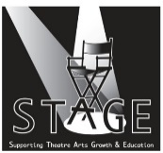  The success of our program depends on student AND parent involvement! In 2013, Our Tiger Drama parents established a 501c3 organization known as STAGE (Supporting Theatre Arts Growth and Education). STAGE assists in fundraising, scholarships, publicity, costume construction, concession/ticket sales, and planning special events. If your student becomes involved in one of our productions, you will receive an email with volunteer opportunities and ways you can help support your student’s participation.  Everyone is welcome at our meetings. Please consider joining STAGE and stay tuned for more information about how you can help support educational theatre in our school! | SPS REPORT CARD ACHIEVEMENT DESCRIPTORS:  Class rubrics will follow point scale that reflects these descriptions.  A - Highly Proficient Understanding – The student demonstrates highly proficient understanding of the required course standards based on content rubrics. The student comprehensively grasps and applies the key concepts, processes and/or skills.  B - Proficient Understanding – The student demonstrates proficient understanding of the required course standards based on content rubrics. The student grasps and applies the key concepts, processes and/or skills.  C - Approaching Understanding – The student is approaching proficient understanding of the required course standards based on content rubrics. The student grasps and applies some key concepts, processes and/or skills.  D - Minimal Understanding – The student demonstrates minimal understanding of the required course standards based on content rubrics. The student struggles to grasp and apply the key concepts, processes and/or skills.  F - Insufficient Understanding – The student is not demonstrating sufficient understanding of the required course standards based on content rubrics, and/or student has difficulty applying the key concepts, processes and/or skills.

Course Standards
CREATE
Generate and conceptualize…organize and develop…refine and complete artistic work.
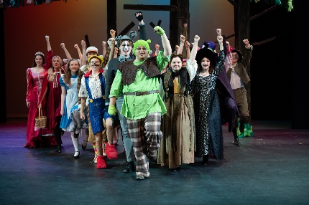
Shrek – 2020
PERFORM
Select, analyze and interpret…develop and refine artistic techniques…convey meaning through presentation of artistic works.
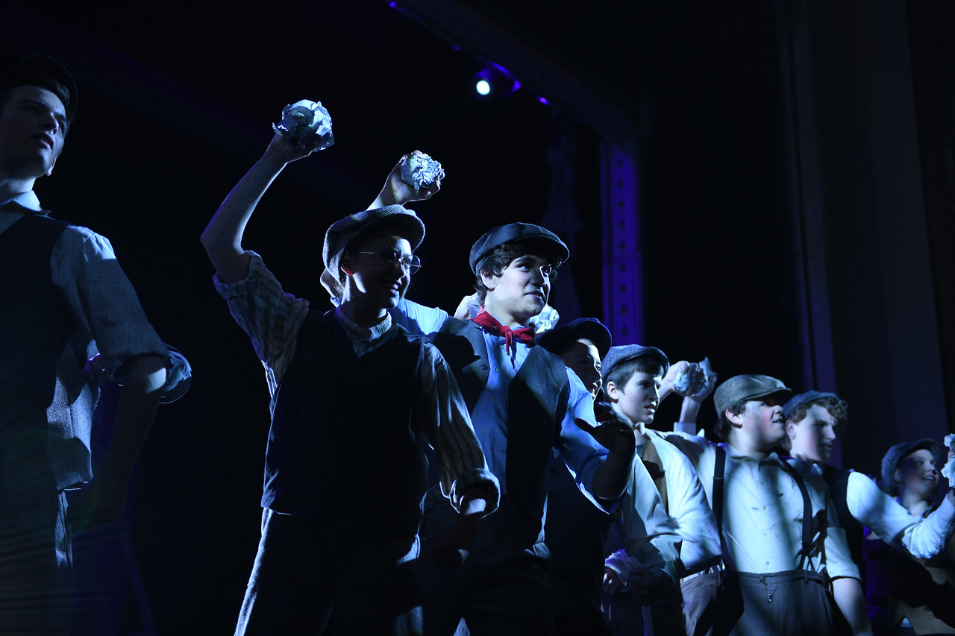
Newsies - 2019
RESPOND
Perceive and analyze…interpret intent and meaning…apply criteria to evaluate artistic work.
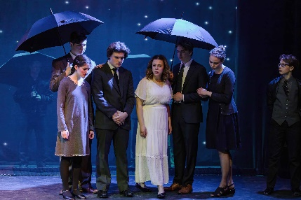
Our Town - 2022
CONNECT
Synthesize and relate knowledge and personal experiences…relate work with societal, cultural, and historical context to deepen understanding.
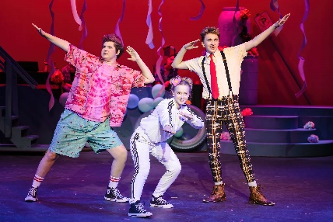
The SpongeBob Musical- 2021
Musical Theatre
Mr. Pschirrer – Room 129
gregp@spokaneschools.org
www.tigerdrama.com
Mission | To provide our students and community opportunities for entertainment, enrichment, & education through exceptional theatre arts and the applicable life skills theatre develops.
Vision | Tiger Drama establishes an environment where all members challenge themselves as individuals, collaborate with others to create their best work now, and connect with other artists in and outside Lewis & Clark High School to be lifelong supporters of the arts.
Expectations
Engage. To get something out of this class, you will need to commit to your work. Listen, put forth effort, and avoid distractions (especially personal devices!)
Be Bold. Take risks. Make choices. Try things without the guarantee of success. Taking chances and truly engaging in discovery are the keys to learning.
Show Respect. For this class to be successful, we must feel safe and comfortable. Show respect for your teacher, yourself, and your classmates. Do work that you can be proud of and come prepared to listen and participate.

Grading/Late Work
For more information, see District Grading Policy document Procedure 2420
OPENING NIGHT, CLOSING NIGHT, and SPRING PRODUCTION ARE MANDATORY PERFORMANCES FOR ALL MT STUDENTS.
Grading is based on meeting course standards and rubrics will be used to assess standards/provide feedback.
In a performance-based class, each student’s involvement impacts every other student’s learning opportunities.
You will not be able to demonstrate learning if you do not actively participate.

CREATING - Direct involvement in class activities and interaction with the rest of the class. You’ll have a hard time meeting this standard if you struggle with tardiness/attendance.
PERFORMING – Talent is not a consideration in grading/meeting a standard. You demonstrate your learning through setting and meeting goals throughout the year. If you are unprepared to perform, it demonstrates that you have not met the standard and your grade will reflect that.
RESPONDING – Consistent reflection is how we grow. As you respond to your own work and the work of your peers, your skills will develop, and you will demonstrate the variety of skills you are learning in this class.
CONNECTING – You will demonstrate meeting standards in this area through your critiques and sharing your thoughts in class discussions/activities.

LATE WORK - 10% reduction per day late. This bottoms-out at half credit.
Late work will only be accepted up to the end of the quarter/designated grade cutoff date.
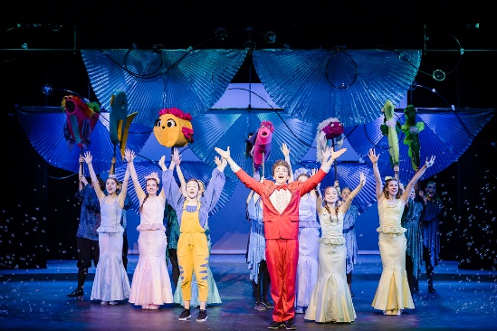  The Little Mermaid - 2021 | Attendance
 | To earn a passing grade, students must spend a great deal of time involved in group activities. Students who are frequently absent/tardy cannot adequately contribute to or demonstrate their learning through group projects. Absence from class impacts everyone’s learning opportunities. Everyone is a vital part of the class, and your presence is required for all of us to be successful. If health concerns impact your attendance, we will pursue alternative ways to demonstrate learning.
Class/Rehearsal Dress Code |  |  |  | 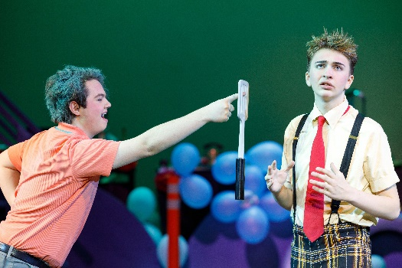  The SpongeBob Musical - 2021
You may leave your rehearsal/dance clothing in the Green Room in your assigned box and change before class. These boxes are for rehearsal clothing and shoes ONLY. The Green Room is NOT YOUR LOCKER and not a place to store books/bags/or other items not directly related to your theatre class. All clothing and shoes should be clearly labeled with your name.
Behavior/Responsibility |  |  | Script Library
Tiger Drama students are representatives of Lewis & Clark and Tiger Drama. Your behavior outside the classroom, around the community and even online should reflect your responsibility as a good representative of what Tiger Drama stands for. |  |  | Check out privileges are available to students who follow correct procedures for signing out and promptly returning scripts and books in good condition or pay the cost to replace it. Please let Mr. Pschirrer know if you would like to take a script and he will check it out to you.
2022-2023 Important Dates |  | Outside Requirements
September 12/13 Opening Night Auditions  September 26/27 Legally Blonde Auditions  October 6 Opening Night  October 29 INTAF @Ferris High School  December 8-10 Legally Blonde Performances  December 14 Thespy Registration Deadline  January 9/10 Sense & Sensibility Auditions  January 14 Thespy East Regional Event  March 9-11 Sense & Sensibility Performances  March 16-18 State Thespian Festival @ WWU  March 29 AT Performance and Showcase  April 20-22 Frozen Performances  May 1/2 Closing Night Auditions  May 24 Thespian Induction & Award Night  May 25 Closing Night  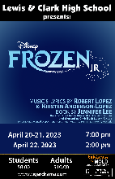  School Day Performance:  April 18  Performances:  April 20-21 – 7:00pm  April 22 – 2:00pm |  | You are required to view one theatrical event per semester and complete a critique of the performance. Critique guidelines are available at tigerdrama.com.  All students in Musical Theatre participate in Opening and Closing Night Showcases. These are mandatory performances and are part of your grade.  Students in Musical Theatre also participate as cast or crew in our Spring Production. Auditions and rehearsals are held within class. There are minimal Dress Rehearsals and Performances outside of class.
 |  | Critique Due Dates
 |  | Jan. 5 and May 18
 |  | Class Remind
Our class Remind code is @lcmt2022.
Please be sure Remind notifications are enabled on your phone.
Participant Name___________________________

Class/Period__________________________

Musical Theatre Participant & Parent/Guardian CONTRACT
- I understand that this is a performance class and I WILL be required to memorize material and I WILL be required to perform in front of the class.
- I understand that Opening Night and Closing Night are mandatory performances for all students enrolled in Musical Theatre. I understand I am required to attend one evening dress rehearsal for each of these performances (usually the evening before).
- Our Spring Production has in-class rehearsals and a limited after-school rehearsal period and performances. Participation and attendance are mandatory as these productions are part of the curriculum.
- I understand that I will edit my content for appropriateness both in my everyday discussions and class performance material. Direct any questions about content to Mr. Pschirrer.
- I understand that a requirement of Musical Theatre is the viewing of 2 outside theatrical events per semester and write a critiques on the performances.
- I understand that I need to bring appropriate dance/rehearsal clothing and footwear to class. I will also be responsible for taking items home and washing them.
- I understand that there may be some cost associated with participation in the program including limited costume materials (shoes, undergarments, personal accessories, etc.).
- I give my consent for any production images and/or footage of my student to be used for any promotional and/or archive use.

We ask that parents/guardians avoid restricting their student’s involvement in any production after the student has been cast. Productions are contingent on ALL participants. If there are problems that could bar a participant from continuing in the show, we need to know as soon as possible to arrange a replacement.

I have read and understand the course syllabus and the actor & parent/guardian contract. I acknowledge that, by signing, I am indicating my willingness to follow class expectations.

Student’s Name (Printed) _______________________ Student’s Signature __________________________

Parent/Guardian Name (Printed) ______________________________________________________________

Parent’s Preferred Email Address(es) ________________________________________________________

The success of our program depends on student AND parent involvement! In 2013, Our Tiger Drama parents established a 501c3 organization known as STAGE (Supporting Theatre Arts Growth and Education). STAGE assists in fundraising, scholarships, publicity, costume construction, concession/ticket sales, and planning special events. If your student becomes involved in one of our productions, you will receive an email with volunteer opportunities and ways you can help support your student’s participation.  Everyone is welcome at our meetings. Please consider joining STAGE and stay tuned for more information about how you can help support educational theatre in our school! | SPS REPORT CARD ACHIEVEMENT DESCRIPTORS:  Class rubrics will follow point scale that reflects these descriptions.  A - Highly Proficient Understanding – The student demonstrates highly proficient understanding of the required course standards based on content rubrics. The student comprehensively grasps and applies the key concepts, processes and/or skills.  B - Proficient Understanding – The student demonstrates proficient understanding of the required course standards based on content rubrics. The student grasps and applies the key concepts, processes and/or skills.  C - Approaching Understanding – The student is approaching proficient understanding of the required course standards based on content rubrics. The student grasps and applies some key concepts, processes and/or skills.  D - Minimal Understanding – The student demonstrates minimal understanding of the required course standards based on content rubrics. The student struggles to grasp and apply the key concepts, processes and/or skills.  F - Insufficient Understanding – The student is not demonstrating sufficient understanding of the required course standards based on content rubrics, and/or student has difficulty applying the key concepts, processes and/or skills.

Chicago - 2008
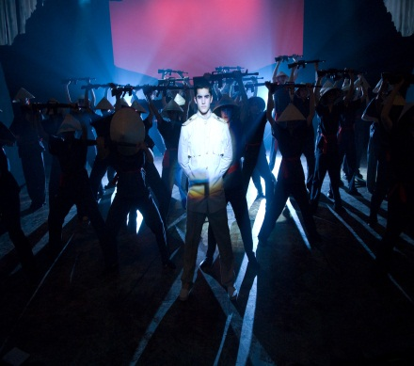
Miss Saigon - 2008
Stagecraft
Mr. Pschirrer – Room 129
gregp@spokaneschools.org
www.tigerdrama.com
Course Objective
Stagecraft participants explore and create technical theater elements for our productions. This includes lighting, sound, makeup, scenic design and construction, costumes, publicity, and stage management. Students also explore the elements of design and research by creating their own design projects. Outside class work on a crew for our productions and concerts is a class requirement.

Mission | To provide our students and community opportunities for entertainment, enrichment, & education through exceptional theatre arts and the applicable life skills theatre develops.
Vision | Tiger Drama establishes an environment where all members challenge themselves as individuals, collaborate with others to create their best work now, and connect with other artists in and outside Lewis & Clark High School to be lifelong supporters of the arts.
Outside Class Requirements
Stagecraft does require some time & work outside of class. As a requirement for each semester you must:
- See TWO outside productions and write a technical critique of the lighting, sound, scenic, and costume elements of the show.
- Put in 5 hours working on an outside event in the LC auditorium. This can include working crew for a LC production or other concerts/events.
- When there is a con, we are all responsible for setup as well as breaking down the con during lunch. This is a REQUIREMENT and GRADED participatory activity.

Shop Safety |  |  |  |  | 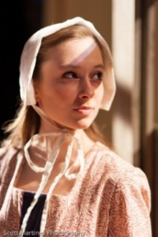  The Crucible – 2012  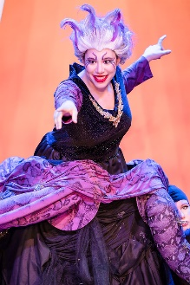  The Little Mermaid - 2022
Your personal safety is the highest consideration. If misused, the tools we operate in class can cause severe injury and even death. To provide the safest working environment in the shop, the following rules are strictly enforced:
- Wear closed-toe, low-heel shoes.
- Jewelry must be removed before operating any machinery.
- Long hair must be tied back away from the face.
- Eye protection must be worn when operating any motor-driven tools.
- Medications You must not use any tools if you are taking medicines that affect your ability to operate the tools safely. (Ex. cold medications cause drowsiness.)
- Do not work in the shop alone.
- Wear clothing you don’t mind getting dirty.
If you come to class dressed inappropriately, you will not be allowed to participate and counted as absent.
Any purposefully dangerous behavior that threatens the safety of anyone in the shop will result in expulsion from the class.
 | Attendance
 | To earn a passing grade in Stagecraft, attend class and actively participate. Be proactive. If you finish a task, find or ask for a new one. Attendance points are given on a daily basis. If you are not in class, you will not receive the points for that class regardless of the reason for the absence. These points cannot be made up.
 | 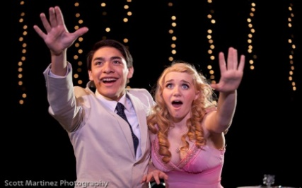  Legally Blonde - 2011 | Absences from Stagecraft class are serious. If you miss History or English, what you missed does not have any direct effect on your classmates. In Stagecraft, if you miss the day we talk about the use and safety of a power or hand tool, what you do not know can be dangerous to others. For that reason, the absence policy is stricter in Stagecraft than it might be for other classes. If you've missed a day when we've discussed "use and safety of…" topics, you won't be allowed to use those tools until you've been trained.
 | Tardiness |  |  | 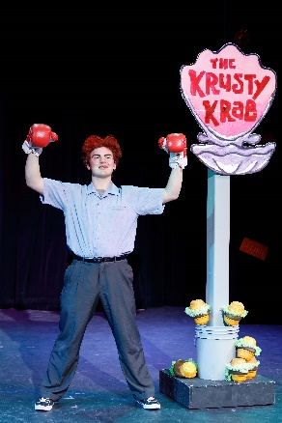  The SpongeBob Musical - 2021
 | Roll is taken at the beginning of each class. If you arrive late, it is your responsibility to contact Mr. Pschirrer to let him know you arrived. If you do not, the marked absence will stand and you will receive half-credit for the period.
Grading/Late Work
For more information, see District Grading Policy document Procedure 2420
 | - 21st Century Job Skills  - Class participation |  | - Critiques (one per semester)  - Design Projects/Reflections
LATE WORK - 10% reduction per day late. This bottoms-out at half credit.
Late work will only be accepted up to the end of the quarter/designated grade cutoff date.

2022-2023 Important Dates
September 12/13 Opening Night Auditions
September 26/27 Legally Blonde Auditions
October 6 Opening Night
October 29 INTAF @Ferris High School
December 8-10 Legally Blonde Performances
December 14 Thespy Registration Deadline
January 9/10 Sense & Sensibility Auditions
January 14 Thespy East Regional Event
March 9-11 Sense & Sensibility Performances
March 16-18 State Thespian Festival @ WWU
March 29 AT Performance and Showcase
April 20-22 Frozen Performances
May 1/2 Closing Night Auditions
May 24 Thespian Induction & Award Night
May 25 Closing Night
Critique Due Dates:
Jan. 5 and May 18

How to do Well
- Attend class and get involved. If you attend class but are habitually ill-prepared to participate in the discussions or are lethargic towards your shop work, it will adversely affect your grade. This class is all about being a team and being a family. If you are missing (even if the absence is excused) our team cannot function properly.
- Show off. Demonstrate your knowledge, skills, and ideas. Demand perfection from yourself and don’t settle for less. LC prides itself on our production technical elements. You are now a vital part of this family.
- Have a plan and communicate if you know you will be absent.

Class Remind
Our class Remind code is @lcscraft.
Please be sure Remind notifications are enabled on your phone.

Participant Name___________________________

Class/Period__________________________

Beginning/Intermediate Theatre/Stagecraft
PARTICIPANT and PARENT/GUARDIAN CONTRACT

- I understand that Beginning/Intermediate Theatre are performance classes. I WILL be required to memorize material and I WILL be required to perform in front of the class.

- I understand that I will edit my content for appropriateness both in my everyday discussions and class performance material. Direct any questions about content to Mr. Pschirrer.

- I understand that one of the requirements of Intermediate Theatre and Stagecraft are the viewing of theatrical events and completing a critique of the performances.

- I understand that I will need to wear appropriate rehearsal clothing and footwear to class.

- I understand that there may be some costs associated with participation in the program if I choose to be involved in extra-curricular productions.

- I give my consent for any production images and/or footage of my student to be used for any promotional and/or archive use.

We ask that parents/guardians avoid restricting their student’s involvement in any production after the student has been cast. Productions are contingent on ALL participants. If there are problems that could bar a participant from continuing in a show, we need to know as soon as possible to arrange a replacement.

I have read and understand the course syllabus and the actor & parent/guardian contract. I acknowledge that, by signing, I am indicating my willingness to follow class expectations.

Student’s Name (Printed) _______________________ Student’s Signature __________________________

Parent/Guardian Name (Printed) ______________________________________________________________

Parent’s Preferred Email Address(es) ________________________________________________________

The success of our program depends on student AND parent involvement! In 2013, Our Tiger Drama parents established a 501c3 organization known as STAGE (Supporting Theatre Arts Growth and Education). STAGE assists in fundraising, scholarships, publicity, costume construction, concession/ticket sales, and planning special events. If your student becomes involved in one of our productions, you will receive an email with volunteer opportunities and ways you can help support your student’s participation.  Everyone is welcome at our meetings. Please consider joining STAGE and stay tuned for more information about how you can help support educational theatre in our school! | SPS REPORT CARD ACHIEVEMENT DESCRIPTORS:  Class rubrics will follow point scale that reflects these descriptions.  A - Highly Proficient Understanding – The student demonstrates highly proficient understanding of the required course standards based on content rubrics. The student comprehensively grasps and applies the key concepts, processes and/or skills.  B - Proficient Understanding – The student demonstrates proficient understanding of the required course standards based on content rubrics. The student grasps and applies the key concepts, processes and/or skills.  C - Approaching Understanding – The student is approaching proficient understanding of the required course standards based on content rubrics. The student grasps and applies some key concepts, processes and/or skills.  D - Minimal Understanding – The student demonstrates minimal understanding of the required course standards based on content rubrics. The student struggles to grasp and apply the key concepts, processes and/or skills.  F - Insufficient Understanding – The student is not demonstrating sufficient understanding of the required course standards based on content rubrics, and/or student has difficulty applying the key concepts, processes and/or skills.

